zeenatsaeed93@gmail.com
ZeENAT SAEED F2024332108
OPERATING SYSTEMS TAsK#03

Calculator Task
CODE:
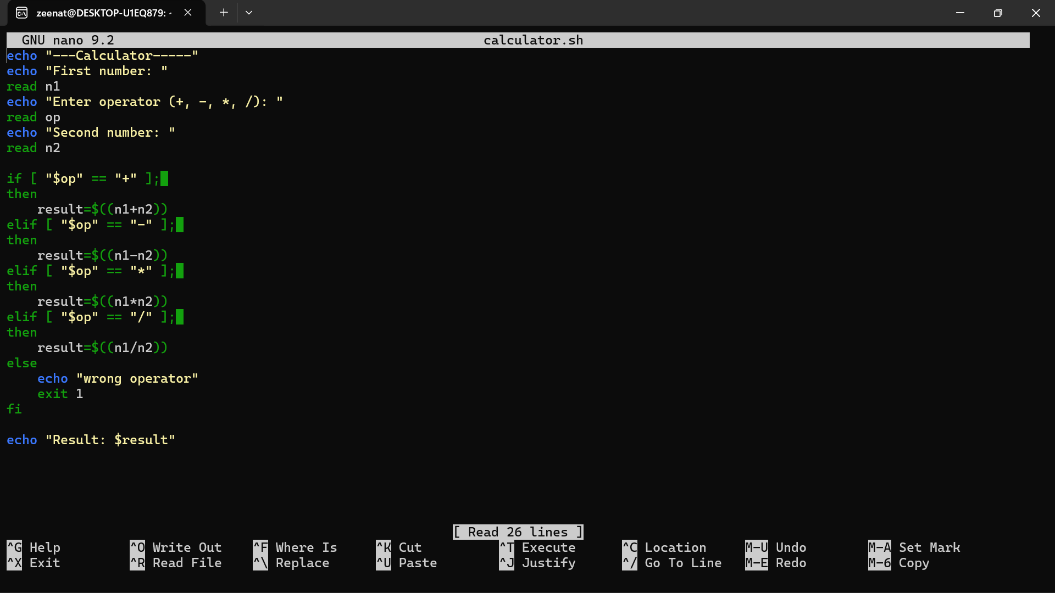

Output:


